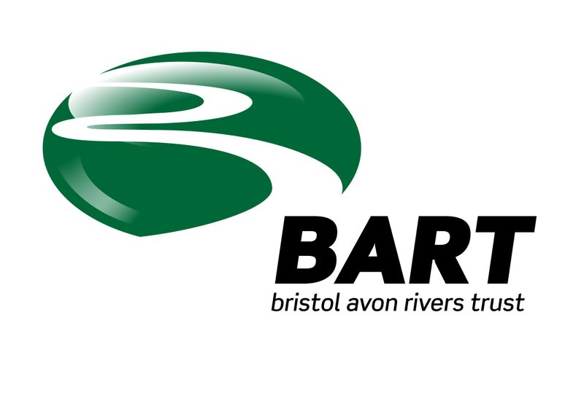 28 August 2014

100,000 JUVENILE EELS INTRODUCED TO WILTSHIRE WATERWAYS IN EMERGENCY CONSERVATION BOOST

A major project to increase the number of critically endangered European Eels in Wiltshire’s River Avon will start at 2pm on Thursday 28 August when nearly 100,000 juvenile eels will be introduced at several specially selected sites in the “middle catchment” – the area around Chippenham.
The fish were caught in the Severn estuary in April this year, and have spent the summer being fed and grown in a special facility run by UK Glass Eels in Gloucester, ahead of their big relocation to Wiltshire.
The number of eels in all the UK’s river systems has dropped significantly in the last 30 years, but scientists have been encouraged to see recent increases in the number of baby eels (called glass eels) arriving from breeding grounds in the Sargasso Sea (near Bermuda).
Spring 2014 was a bumper year, the best for 30 years, with hundreds of millions of glass eels arriving in west facing estuaries.
The Avon is an ideal habitat for eels to grow and mature, but eels find it very difficult to migrate upriver because of the number of man-made barriers blocking their route.
To help move these tiny fish past the 30 plus barriers and into habitats that they need to mature in for the next 10 years the Sustainable Eel Group, the Rivers Trusts and UK Glass Eels have launched an emergency relocation programme using techniques honed in Scandinavia, (including unique marking to help scientists monitor their progress) but rarely used in the UK. Until now.
The total costs of this exercise have been estimated at £100,000.
Andrew Kerr, Chairman of the Sustainable Eel Group explains “We give the eels a much better chance of survival by feeding them and then releasing them before the onset of the cold weather. Eels travel thousands of miles to get here, and only the tiniest fraction survive the journey when trapped the wrong side of the barriers. So they need our help to reach the lush inland habitats in order to grow into adults, and then return to the Sargasso Sea to breed again.
“In the long term we need to clear or bypass the barriers so the fish can make this journey on their own. But while we have an abundance of eels arriving in the south west’s estuaries, we need to take emergency measures to help the fish reach their ideal destinations.”
Ian Mock of the Bristol Avon Rivers Trust commented “50 years ago the Avon would have been teeming with eels – it’s the perfect habitat for them with its insect rich, multi tributary waterways. We’re working closely with partner organisations like the Environment Agency, water companies and conservation groups to improve fish passage on the Avon, and have made great progress. Meantime we also recognise the importance of using nature to help us. We’ve seen a huge number of glass eels arriving in the UK this year, and we want to get them back into the best habitats.”
“We are grateful for the permissions and support from the Bristol Avon angling clubs and landowners, in particular Somerford Fishing Association and Bristol Amalgamated Fisheries Limited. Without this support action to help eels and improve our rivers would be much more difficult."
Much of the funding for the eel relocation programme was contributed to the Sustainable Eel Group and the Bristol Avon Rivers Trust as mitigation for enforcement undertaking following an accidental pollution incident in 2013.
Read more about the Sustainable eels Group at: http://www.sustainableeelgroup.com

- Ends –

Media invitation for interviews and photographs:
The eels will be released at several sites on Thursday 28 August from 2pm. Please join us at
Kingsmead Mill near Little Somerford Grid Reference ST9543984504.
To reach Kingsmead Mill firstly navigate to Great Somerford near Malmesbury in Wiltshire - ST96353 82659. Travel through Great Somerford in the direction of Little Somerford ( along Top Street , Park Lane , then Field View) and look out on your left for Mill Lane - ST96595 84166 which you will follow all the way to the Mill. You will be met at an anglers car park by a small lodge on the right - ST95890 84404, where we will meet you to discuss access arrangements.

For more details please contact:
Sustainable Eel Group: Andrew Kerr 07887 993924
Simon Soffe 07887 850420

